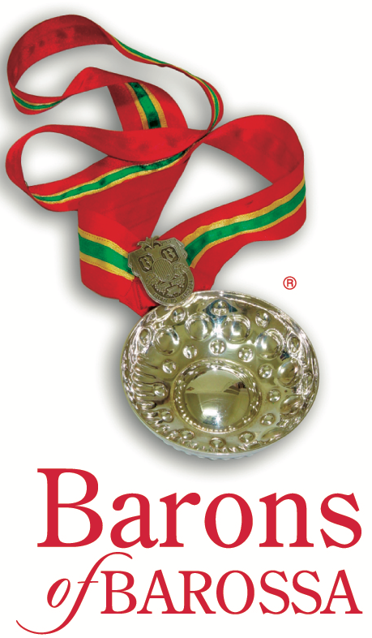

BAROSSA WINEMAKER OF THE YEAR

Anyone is welcome to nominate someone for Barossa Winemaker of the Year who they feel embodies the following criteria.

Definition of a Barossa Winemaker
- A currently practicing winemaker
- A commercial producer of wine in the Barossa
- A winemaker who primarily utilises Barossa grapes

Selection Criteria
Includes any combination of the following:
- Has made a positive contribution to the Barossa wine industry
- Adheres to quality standards to produce Barossa wines of excellence
- Has been recognised at domestic and/or international wine shows/exhibitions, has received winemaking awards or other recognition
- Produces wine that exhibits and respects the regionality of Barossa grapes
- Generously shares their knowledge on an informal or formal basis with others in the region
- Actively contributes to the Barossa community

Annual Selection Process
- Selection panel may be drawn from:
  - Barons of Barossa
  - Barossa Grape & Wine Association
  - Independent suitably qualified people nominated at the Barons of Barossa discretion
- Nominated winemaker to be made aware of his/her responsibilities prior to acceptance

Award Presentation
- Presentation at Declaration of Vintage (3rd Sunday in February)
- Presented to the individual winemaker, not to his/her company

Responsibilities of the Barossa Winemaker of the Year
- To participate in the promotion of the Barossa and The Barossa Cellar (as possible) when requested by the Barons of Barossa or Barossa Grape & Wine Association Executive (this may include attendance at special tastings, assist with/host visiting media, trade and VIPs)
- To host or assist with the annual Barons First Taste of Vintage
- To attend the following year’s Declaration of Vintage and participate in the recognition of that year’s recipient

